**Website Consultancy**

**Hem Korat**

**Table of Contents**

**Executive Summary** 3

**Introduction** 3

**Scope** 3

**Use Cases** 4

**Use Case Diagram** 5

**Software Development Methodology** 5

**Project Timeline** 6

**Known Bugs and Limitations** 6

**Reflections** 6

**Appendix: Source Code** 6

# **Executive Summary**

Our website consultancy project uses HTML, CSS, Express.js, and Node.js to create visually appealing online platforms for businesses. We focus personalized solutions that reflect each client's own identity and goals.   
  
By integrating straightforward design with innovative technologies, we ensure that websites are not only visually appealing but also useful and entertaining across all devices. From concept to launch and beyond, we put client pleasure first and strive for excellence in all aspects of our service.  
  
In a digital era where online presence is critical, our consultation project stands out as a dependable partner in navigating the complexity of the web, driving success for organizations via innovation and experience.

# **Introduction**

Welcome to Frontup Website Consultancy service! We're here to help businesses like yours shine online. Our experienced team specializes in guiding you towards your digital goals with tailored solutions.

At Website Consultancy, we understand the importance of a well-designed website in today's competitive world. Whether you're a small startup or a big company, we're here to meet your specific needs and drive meaningful results.

We focus on user experience, functionality, and performance. By working closely with you, we analyse your website, pinpoint areas for improvement, and make strategic changes. Our aim is to empower you with the knowledge and tools to succeed online, providing ongoing support every step of the way.

Whether you need a website makeover, better search engine visibility, or increased user engagement, Website Consultancy has got your back. Let us partner with you on your journey to digital success.

Our website consultancy platform is built using HTML, CSS, Node.js, and Express.js. These technologies allow us to create dynamic and interactive web applications tailored to your specific needs. Additionally, our database is powered by XAMPP and phpMyAdmin, ensuring secure storage and efficient management of your data.

With our expertise in web development and consultancy, combined with the latest technologies, we're equipped to handle any project and help you achieve your digital objectives effectively. Let's work together to elevate your online presence and propel your business to new heights.

# **Scope**

**Website Analysis and Improvement:**

* We'll carefully review your website, identifying areas to make it work better for your business.
* Our aim is to enhance user experience, boost performance, and improve search engine visibility.

**Tailored Strategies and Recommendations:**

* Together, we'll set clear goals and create a roadmap to achieve them.
* Expect personalized advice on design, content, SEO, and digital marketing strategies.

**Website Development and Support:**

* Our team will use modern technologies to build and enhance your online presence.
* We'll ensure it's responsive, user-friendly, and equipped with the features you need.

**Continuous Improvement and Collaboration:**

* We'll track performance, gather feedback, and make improvements over time.
* Expect open communication and collaboration throughout our partnership.

# **Use Cases**

**Client Login/Register**: A client can register and login to website to give task or project to development team.

**Client Project Submission**: A client goes to the website and submits a project request, including information such project requirements, goals, and deadline. This use case commences the collaboration process between the client and the development team.

**Project Dashboard**: Once submitted, the project is assigned a unique identification and placed to the dashboard.

**Project Completion and Archive**: Once the project has been completed and the website is operational, all project-related documentation and assets are stored for future reference.

**Feedback**: Once the project has been completed and the website is operational, client can share their feedback with us, so that we can improve our services.

# **Use Case Diagram**

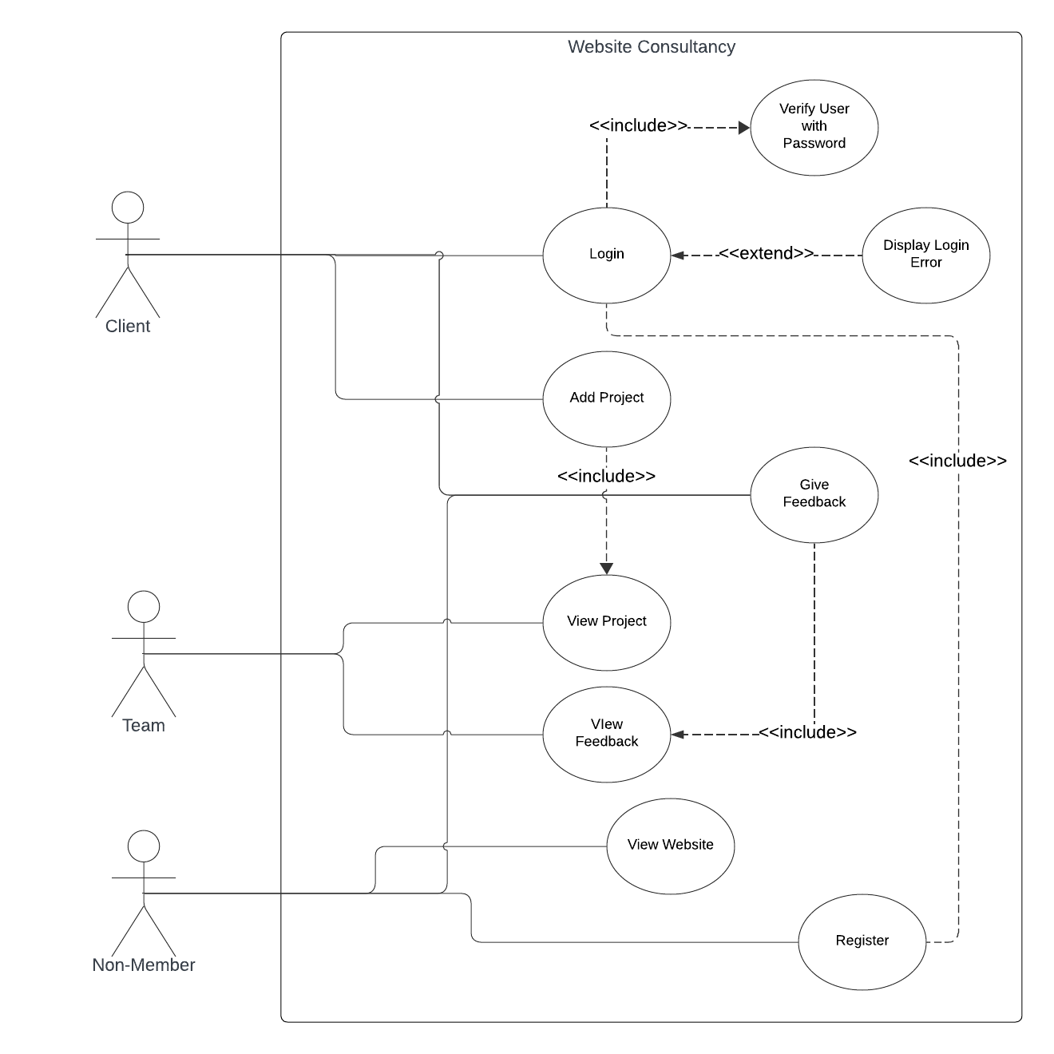

# **Software Development Methodology**

In our website consultancy project, we've adopted an Iterative and Incremental Development Methodology (IID) alongside the Scrum Framework to ensure a flexible and efficient approach to our work. This means we're breaking down our project into smaller, manageable pieces, allowing us to continuously refine and enhance our work as we progress. With IID, we gather feedback early and often, adapting to changing requirements and priorities seamlessly.

The Scrum Framework provides us with a structured framework for organizing and managing our project. We work in short, focused bursts called sprints, typically lasting a few weeks. During each sprint, we set specific goals and tasks, collaborating as a team to achieve them. At the end of each sprint, we review our progress, gather feedback, and plan our next steps accordingly.

By combining IID with the Scrum Framework, we're able to maximize efficiency, minimize risks, and deliver high-quality results that meet our clients' needs. It's all about staying agile, staying focused, and continuously improving as we work towards our shared objectives.

# **Project Timeline**

# **Known Bugs and Limitations**

We have many limitations like we can’t give it to any single team members and, we can have any dashboard for just teams. That is because lack to time and due to lack of resources. I have made simple but also to achieve goals and requirement for passing this course.

# **Reflections**

Looking back at our website project, I feel proud and happy. We had some tough times, but we learned a lot and had fun together.

Even when things got hard, we didn't give up. We love making websites and helping people, so we kept going. Every time we finished a website, it felt amazing to know we were helping someone's business.

But the best part was making friends along the way – with the people we worked for and with. We learned that teamwork and friendship are super important.

Now, we're excited for what's next. We've learned a lot and we're ready for more adventures in making awesome websites.

# **Appendix: Source Code**